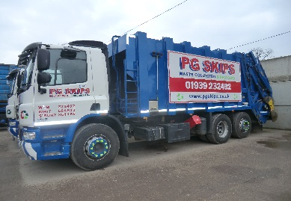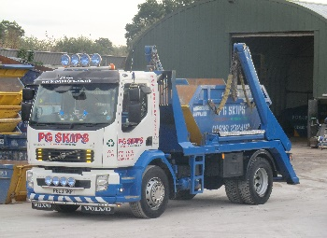 PG Skips Ltd

Lowe Cottage Farm, The Lowe,

Wem, Shrewsbury, SY4 5UE

Skips 01939 232492 Company Registration No: 4036876 Bins 01939 236372

Email: **sales@**[**pgskips.co.uk**](mailto:pgskips.co.uk) Fax 01939 233005 Email: [**bins@pgskips.co.uk**](mailto:bins@pgskips.co.uk)

**Environmental Policy Statement**

Environmental Policy Statement PG Skips Ltd acknowledges the requirement to operate our business undertaking in a manner which reflects good environmental management. We shall demonstrate our commitment to comply with all relevant environmental legislation and minimise pollution, resource use and waste, where feasible, through the continual improvement of performance in all areas of our company.

 PG Skips Ltd shall be committed to identify all activities that have the potential to cause an environmental impact, as well as providing adequate resources to help minimise or prevent any negative impact.

 To achieve this commitment, we will:

Identify all environmental impacts that the Company contributes to and establish environmental management procedures that can be incorporated into all business decisions, in a cost-effective manner. Regularity measure and evaluate our environmental performance and improve where necessary. Promote a culture of continual environmental improvement within the Company. Delegate the responsibility for environmental matters to the appropriate levels in the Company. Consistently increase the awareness and provide necessary training to all our employees and customers to ensure environmentally responsible concepts are integrated into their normal working practices. Demonstrate control of all our operations and ensure that all are performed with due consideration of the environment. Identify and mitigate against potential accidents that could result in an environmental impact, so that if an accident did occur the consequences would be minimised, use products that have a negligible environmental impact, where appropriate options exist. Minimise the storage and use of all articles and substances providing a substantial environmental hazard, were appropriate. Reduce the consumption of resources (energy, materials, packaging), where feasible, minimise waste through a commitment to reuse, recover or recycle, where feasible, it is our duty to ensure that good environmental management is adopted and maintained and as such PG Skips Ltd will communicate our Environmental Policy to all employees, and it will be made available to customers as required. The Director Peter Griffiths is responsible for the environmental performance of PG Skips Ltd, his signature to this policy statement being acknowledgement of this overall responsibility and commitment.

Signed: P. Griffiths

Peter Griffiths (Director)

Date: 01.08.2024  
Review date: 01.08.2025